P[∆]

TIME is a “known amount” (based on 1/infinity possible decisions on this amount)

Life 🡪 Choice 🡪 P[Y] (possible y variable)

***Automatic*** – Not alive

Is void.

Of choice,

But things

Are happening – sunrises, moon, seas, suns, stars…

***When*** observed,

Felt/ experienced…

By an observer.

Our collective

Mind forms “matter”

That remains in our

“Collective reality” An

Observer can observe “our” collective reality and affects it via cause/ effect

Increase Cause, Increase Effect (creates pulse, more dense, infinitytan) 🡨 Each cluster is a paradox because how to input infinitytan

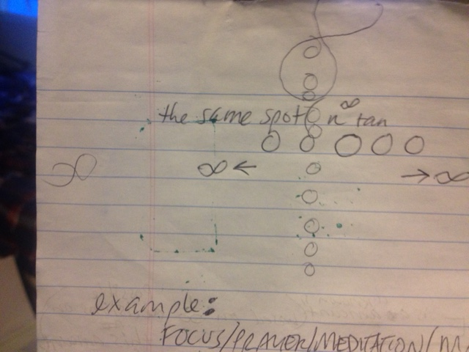

Example:

FOCUS / PRAYER / MEDITATION / MASSIVE OBSERVATION HAPPENING 🡪 EXPERIENCE

Causes X amount of infinitytan to require the same exact spot. How can they be in the same spot / same time?

Answer to this paradox is PERCEPTION. All of this energy is focused and should exist in the same place along this known line of infinity (our collective reality). However, due to perspective (which changes the frequency of our individual energy at that exact known moment in time).

Perspective, all the infinitytan are closely placed but not quite in the same place.